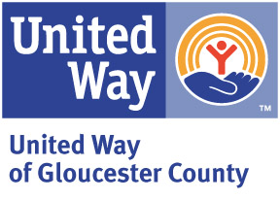

Nomination for

2024 Volunteer Leadership Award

The Volunteer Leadership Award is the United Way of Gloucester County’s highest individual honor, recognizing outstanding volunteer service and leadership to the United Way of Gloucester County. This award was established in 1984 by special action of the Board of Directors and is presented each year at the annual Volunteer Recognition Dinner.

Criteria

- Service and activity as a United Way volunteer
- Activity and affiliations throughout the Gloucester County community
- Length of service
- Impact and influence on the United Way and the Gloucester County community

Nominee’s Name:

Organization:

Address:

Nomination Statement:

Nomination made by: Phone

Past Recipients

Emidio “Mid” Mariani  Lisa Carney  Warren Strumpfer  Patricia McEvoy  Michael Drager  Scott Kintzing  Benjamin Griffith  Jack Eisenman | Richard Dann  Eileen Cardile  Jacquelyn Love  Ed & Kathy Schultes  John Holdcraft, MD  Earle McCloe  Ronald H. Mohring  Cheryl A. Slack | Warner A. Knobe  Darryl T. Harris  Ron Uzdavinis, Esq. Kevin C. Bowen  Robert Hoffman, Ph.D.  Ronald V. Jaworski  Lawrence J. Reader  William B. Long | Howard S. Kroop, MD Amelia B. Kressler  Leo C. Beebe  Dale E. Choate  Charles S. Homan  Kenneth Clay, Ed.D  Richard E. Craven  Edith S. Huston | William H. Campbell Jeanne M. Trescott  Thomas H. Wood
Please return by Friday, March 29th to lrezendes@uwgcnj.org or fax to 856-384-1812

