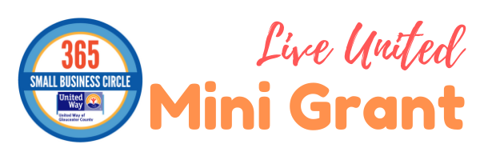
2020 United Way of Gloucester County
"LIVE UNITED" Mini-Grant Application
(complete as a “Word” document)

Organization Information:
Name:
Address:
City: |  | State: | Zip code:
Phone:
EIN Number: | Website:

Contact Person:
Name: Title:
Address (if different from above):
City: | State: | Zip code:
Email: | Phone:

Program/Project Information:

Name: | Requested Amount: (up to $1,500 max.)

Brief Description of the Program/Project: (500 words or less using 10 to 12 point font size) (furnish start and end date or ongoing)

Mission Statement:

Describe the Impact for the Community: Describe the planned use for the grant. State exactly the use of the
funds and how the people you serve will benefit. Estimate the number of people who will be served.

Budget (up to $1,500 maximum funding):
- Provide a brief “line item” description and the corresponding amount. The total of all items should equal to the request amount. The numbers should be rounded. (Example: Curriculum Materials - $250.00)

______________________________________________________ $_____________
______________________________________________________ $_____________
______________________________________________________ $_____________

______________________________________________________ $_____________
TOTAL $_____________

- Which focus area categorizes your program? (Health, Education, Financial Stability) _______________
- How will the agency recognize this funding? _______________________________________________

THE APPLICATION AND DOCUMENTATION MUST BE MAILED TO BE RECEIVED BY TUESDAY, 7/14/20, 4:00 PM
THE 2-PAGE APPLICATION MUST ALSO BE EMAILED TO BE RECEIVED BY TUESDAY, 7/14/20, 4:00 PM
Contact Information:
Nicole R. Morse
Director of Community Initiatives, United Way of Gloucester County
856.845.4303 x13 | nmorse@uwgcnj.org
www.uwgcnj.org
454 Crown Point Rd, Thorofare, NJ 08086

