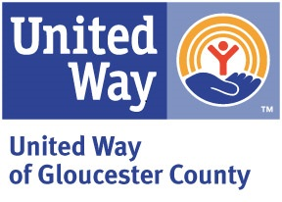
United Way of Gloucester County
2023 Sponsorship Program

Company Name:
Address:
Contact Person:
Telephone: Email:
[ ] Platinum Sponsor - $5,000 [ ] Gold Sponsor - $2,500
[ ] Silver Sponsor - $1,500 [ ] Bronze Sponsor - $500
Our donation is: [ ] Enclosed [ ] Please Invoice [ ] Will be sent separately
Sponsorship Level | Platinum | Gold | Silver | Bronze
Amount | $5,000 | $2,500 | $1,500 | $500
Recognition as Lead Corporate Partner for 2023 Volunteer Leadership Event (Held in Spring 2024)
Multiple public recognition opportunities as corporate partner through media outlets
Spotlight in our e-newsletter
Spotlight on UWGC social media platforms
Public recognition as corporate partner through media outlets
Recognition in our e-newsletter
Recognition as event sponsor for 2024 Campaign Kickoff
Recognition as event sponsor for 2023
Thanks for Giving Program
Recognition on United Way website
Shout out on UWGC social media platforms
Recognition in Annual Report - Printed & Digitally distributed
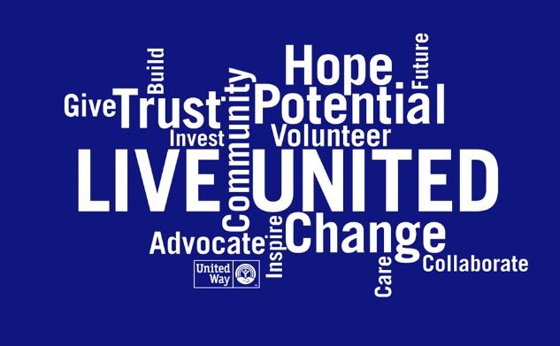
Please return form to:
Donna Murphy, Campaign Director
United Way of Gloucester County
454 Crown Point Rd. Thorofare, NJ 08086
Phone: (856) 845-4303 x180
Fax: (856) 384-1812
Email: donnamurphy@uwgcnj.org

