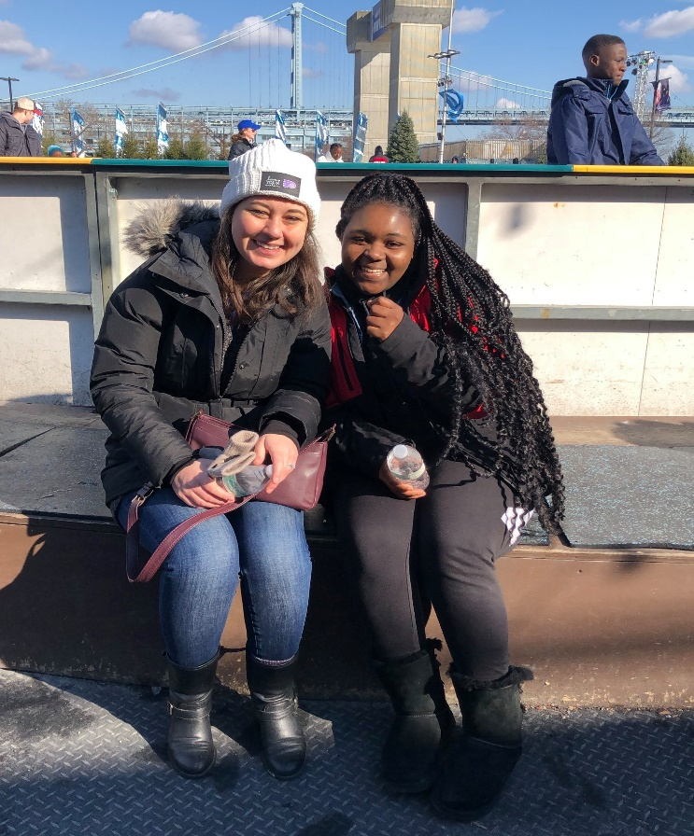

**Big Brothers Big Sisters Independence**United Way of Gloucester County’s support is magnified by the value of dedicated professionally supported volunteer mentors. BBBSI estimates that the value of volunteer time is now $31.80 per hour. At minimum, Bigs spend 48 hours per year with their Littles, a value of $1,526 per youth. The only Gloucester County dedicated funding for our program comes from United Way of Gloucester County. We anticipate serving 30 youth in Gloucester County in the new grant year, including matches as well as youth participating in our Big Cousins program.

**Arc Gloucester’s Camp Sun ‘N Fun**The funding support from United Way of Gloucester County continues to have a critical impact on the Camp Sun ‘N Fun respite program. Especially during and post pandemic, without this support we would not have been able to provide this service to as many campers and their families. Within the last 5 years, the method of federal and state financial support to families for all services has been restructured to a budgeted fee-for-service system, which strains the ability of families to obtain any form of respite care. We would not be able to provide a quality level of care to as many families without the support of United Way of Gloucester County.

**What Impact Has United Way of Gloucester County Had on These Programs…?**