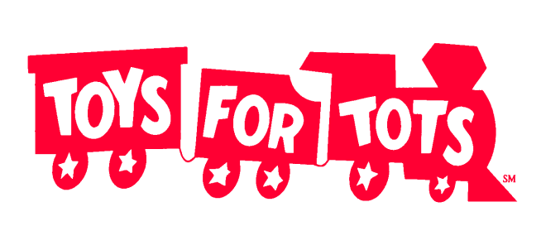

2025 Sign-Up Form

Collection Drive: Wednesday, October 1, 2025 to Wednesday, December 17, 2025
(anytime within this period, or earlier)

Yes, we will participate:

Organization Name: _____________________________________________________

Contact Name: _____________________________________________________

Phone: ___________________ext._____ Email: ______________________________

____We will deliver our items to the Toys for Tots collection site, located at 210 County House Road, Shady Lane Complex, Building E, Clarksboro, 08020 by Wednesday, December 17, 2025. Usual hours of Operation – Monday to Friday, from 10:00 am to 4:00 pm.

___ We need a volunteer to pick up our items on the following day/date: ______________________

PLEASE EMAIL: WENONAH.NJ@TOYSFORTOTS.ORG TO SCHEDULE A PICK-UP,

or call 856-224-8061 or 8063, fax 8064.

If items are to be picked up, please give the complete and exact address where the items will be located:

_____________________________________________________________________________________

_____________________________________________________________________________________
(The items are not to be delivered to the United Way office. Thanks)

__________ We will pick up a collection bin from the United Way on ________________
(United Way of Gloucester County, 454 Crown Point Road, Thorofare, 08086)
__________ We will use our own collection bin

Return to Michael Gower, United Way of Gloucester County, as soon as possible
(E-mail mgower@uwgcnj.org or fax 856-384-1812)

THANK YOU FOR HELPING WITH THIS
IMPORTANT PROGRAM

