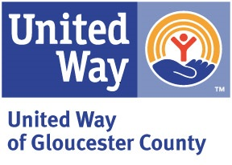

August 2023
Dear Friends,
For more than 65 years, the United Way of Gloucester County has worked with local partners and organizations like yours to address the community’s needs and to face the challenges of tomorrow. We will continue to be the cornerstone for the county to deliver the collective power of GOOD by focusing on Education, Health and Financial Stability for our neighbors.
Your role as a community partner is more important than ever to help us create long-term solutions for our county. Working together, we can create a place where everyone thrives!

We invite you to bolster our campaign efforts by participating in our Annual Sponsorship Appeal. Your support helps us share United Way’s mission and outcomes in various forms :
- creation of campaign video and printed materials
- virtual Employee Campaign Manager training
- training of Loaned Executives
- design and print of annual report
- annual campaign kickoff
- Thanks for giving program
- Volunteer Leadership Event

Your participation in our sponsorship program assures much-needed services including quality early childhood education, job training and coaching, community food programs access to healthcare services, grief and family counseling, as well as access to information and referrals through our 211 statewide program.
Enclosed with this letter is the 2023 Sponsorship Form listing various opportunities of sponsorship for your review. Thank you for creating opportunities of HOPE for your community. We THRIVE when we LIVE UNITED.

Respectfully yours,

Amber Burruezo
2023 Campaign Chair

